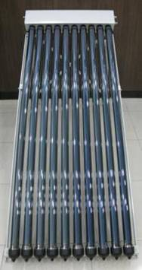

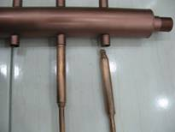

Conventional Specification –Pressurized
Heat pipe insert into manifold and contact with water indirectly. Liquid can be tap water or antifreeze.
Model | Heat pipe Vacuum Tube |  |  | Manifold |  | Frame material | Pressure Resistance  (Mpa) | Absorptive Area  (㎡)
Model | NO.  (pcs) | Outer Dia.  (mm) | Len.  (mm) | Material | Outer covering | Frame material | Pressure Resistance  (Mpa) | Absorptive Area  (㎡)
SC58/10 | 10 | φ58 | 1700 | Copper | Aluminum Alloy | Aluminum Alloy | 0.7 | 0.77
SC58/20 | 20 | φ58 | 1700 | Copper | Aluminum Alloy | Aluminum Alloy | 0.7 | 1.54
SC58/30 | 30 | φ58 | 1700 | Copper | Aluminum Alloy | Aluminum Alloy | 0.7 | 2.31
Using slides to connect each part of frame and adjust location by yourself.

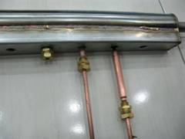
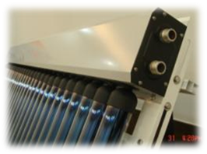

Model | Heat pipe Vacuum Tube |  |  | Manifold |  | Frame material | Pressure Resistance  (Mpa) | Absorptive Area  (㎡)
Model | NO.  (pcs) | Outer Dia.  (mm) | Len.  (mm) | Material | Outer covering | Frame material | Pressure Resistance  (Mpa) | Absorptive Area  (㎡)
SQ58/10 | 10 | φ58 | 1700 | 304 Stainless steel | Aluminum Alloy | Aluminum Alloy | 0.7 | 0.77
SQ58/20 | 20 | φ58 | 1700 | 304 Stainless steel | Aluminum Alloy | Aluminum Alloy | 0.7 | 1.54
SQ58/30 | 30 | φ58 | 1700 | 304 Stainless steel | Aluminum Alloy | Aluminum Alloy | 0.7 | 2.31
Heat pipe insert into manifold and contact with water or liquid directly. Efficiency is better.

Heat Pipe Performance Parameter
Degree of Vacuum | ≧5×10-3 Pa
Material of tube | High Boron Silicon Glass
Size of Condenser Header (mm) | φ16×70
Coating | AL/AL-ALN；Cu/Ss-ALN
Absorptivity | ≧0.86%
Emissivity | ≦0.08%
Highest Temperature Under Sunshine | 250℃
Wind Resistance | 30 m/s
Startup Temperature | ≦25℃
Hailstone Resistance (mm) | 30
Weight of single tube (Kg) | 2.4
Size of single tube (mm) | φ58×1700
Life | ＞10 years

